Title: Forecasting Pacific hake biomass distributions using ocean temperature reveals novel cross-shelf but weak latitudinal effects
Authors:
Jake B. Marshall¹, Lorenzo Ciannelli¹, Michael Malick², Aaron Berger³, Samantha Siedlecki⁴, Mary E. Hunsicker³
Affiliations:
¹College of Earth, Ocean, and Atmospheric Sciences, Oregon State University, Corvallis, OR, USA

²Northwest Fisheries Science Center, National Marine Fisheries Service, National Oceanic and Atmospheric Administration, Manchester, WA, USA

³Northwest Fisheries Science Center, National Marine Fisheries Service, National Oceanic and Atmospheric Administration, Newport, OR, USA

⁴Department of Marine Sciences, University of Connecticut, Mansfield, CT, USA

Abstract
Climate change is driving substantial shifts in the spatial distributions of marine fish species worldwide, creating challenges for fisheries management and the communities these fisheries support. Geographic boundaries and marine spatial planning further complicate these issues, particularly for transboundary stocks spanning the waters of multiple nations. To help inform fisheries management and industry operations, we developed a framework for predicting Pacific hake (Merluccius productus) biomass distributions along the U.S. and Canadian West Coast. Specifically, we used downscaled climate projections from the J-SCOPE ocean forecasting system to make seasonal forecasts of Pacific hake biomass for several age-class groups. We found that (1) temperature at depth slightly enhances forecasts of Pacific hake density and occurrence compared to using only spatial covariates, (2) the influence of temperature on biomass distributions varies across different life stages, and (3) temperature affects hake distribution consistently across all latitudes, reducing the forecasts' utility in informing harvest allocations between the U.S. and Canada. Overall, our results show that temperature anomaly is a useful predictor for Pacific hake biomass distributions, though there is still considerable unexplained variability, suggesting that additional environmental variables could enhance forecasts. Further, our findings suggest that temperature anomaly influences the hake distribution across different ocean depths.

Key words: species distribution model, generalized additive model, delta model, hurdle model, transboundary stock, ecosystem-based management

Introduction
Climate variability and change is driving distribution shifts in living marine resources globally (Morley et al., 2018; Pinsky et al., 2020), posing challenges to fisheries management and conservation (Cheung et al., 2010). In some cases, shifts in distribution are occurring on spatial scales that affect the accessibility of these resources and, therefore, the social systems they support (Greenan et al., 2019; Pinsky & Fogarty, 2012, Selden et al. 2020). The implications of these spatial shifts are particularly crucial for transboundary fish stocks—populations that traverse geographical boundaries, including exclusive economic zones (EEZ) where countries hold exclusive fishing rights. This movement across boundaries often involves complex management and conservation challenges (Palacios-Abrantes et al., 2022). The dynamic nature of marine fish distributions exacerbates this challenge as they do not necessarily align with political borders and are often influenced by environmental conditions (Howard et al., 2021). Species distribution models (SDMs) are an important tool used to help inform management and fisheries' operations in uncertain situations. For example, SDMs have been previously employed to make climate-informed forecasts of species distributions on long-term timescales (Rooper et al. 2021; Liu et al., 2023; Gordó-Vilaseca et al. 2024). SDMs have also been used to make short term forecasts aimed at informing short-term management and fishing operations (Kaplan et al., 2016; Hazen et al. 2018; Malick et al. 2020a). Here, we aim to develop a seasonal biomass distribution forecast model for the transboundary coastal stock of Pacific hake.
Pacific hake (Merluccius productus, hereafter referred to as hake) is a semi-pelagic groundfish species that resides off the West Coast of North America. Hake plays a key mid-trophic role in the California Current Large Marine Ecosystem (CCLME) as both predator and prey, facilitating energy transfer in the ecosystem (Hicks et al., 2013; Ressler et al., 2007). Pacific hake exhibits an annual migratory pattern, characterized by winter spawning along the coasts of Southern California, USA and Baja, Mexico and summer feeding along the productive coasts of northern California, Oregon, Washington, and British Columbia, where it is commercially harvested (Figure 0; Agostini et al., 2006).
Previous research has established that hake migration patterns vary across age classes, with the mean and variation in migration extent increasing with age (Dorn, 1995; Hamel et al., 2015; Malick et al., 2020a; Ressler et al., 2007). In addition, temperature has long been noted as a driver of summertime hake distributions (Agostini et al. 2006; Dorn 1995; Malick et al. 2020a, b; Ressler et al. 2007). While historically this temperature effect was thought to manifest as a simple poleward shift in adult hake distribution during warm years (Ware & McFarlane 1995), recent evidence suggests that the drivers of distribution are more complicated. Malick et al. recently considered the spatially-coarse effects of temperature on hake biomass density for the region spanning from Monterey, California, USA to north of Haida Gwaii, Canada (36.6°N to 54.7°N). In anomalously warm conditions, fully mature hake (ages 5+) are observed in higher densities in Canadian waters and offshore of the shelf break along the coast of southern Oregon and northern California (Malick et al., 2020a). In these periods of warm conditions, actively maturing hake (ages 3-4) are more densely located north of Vancouver Island and offshore along the northern California coast, and juvenile hake that are just beginning to mature (age 2) show no clear spatial relationship with temperature anomalies (Malick et al. 2020a). In anomalously cold conditions, older adults concentrate along the coast of Washington and southern Vancouver Island while semi-mature hake have a propensity to aggregate along the coast from the Oregon-California border to central Vancouver Island (Malick et al. 2020a). The differential effects that temperature anomalies have on different age classes of hake is especially impactful for population distribution, because the coastal population of hake is often heavily dominated by a few strong age classes (Hamel et al., 2015; Ressler et al., 2007), such as the 2021 year class (age 3) in 2024 (Grandin et al., 2024).
Understanding the effect of temperature, as well as other drivers, on hake distributions is important because hake are co-managed through an international Treaty between the United States and Canada that established a fixed allocation of total allowable catch between the two countries (The Agreement, 2004). Since the 1980s, the combined transboundary hake fishery has consistently produced annual catches exceeding 200,000 tons, generating tens of millions of dollars in wages in each country (Grandin et al., 2024). However, hake landings in Canada have considerably declined in recent years to the lowest totals in over 20 years, with only 14.4% of the target catch harvested during 2023 despite an overall ‘healthy’ stock (Grandin et al., 2024). Based on past studies, it has been hypothesized that environmental pressures, such as ocean temperature, dissolved oxygen levels, and food availability, may be driving shifts in hake distribution, potentially causing regional declines in catch.
We developed a framework for producing seasonal forecasts of relative changes in Pacific hake biomass distributions in the northern region of the CCLME along the West Coast of the United States and Canada. Our study aims to provide fisheries managers and industry partners with timely forecasting tools to support informed decision-making regarding the monitoring, management and harvest of this stock. For industry, forecasts can support business planning by anticipating shifts in where hake are likely to occur, helping to optimize vessel deployment and processing logistics. For managers, forecasts can reduce uncertainty about hake distribution across the U.S.-Canada border, aiding in planning limited-effort surveys and promoting bilateral transparency and trust. This tool may also serve as an early warning system for ecological shifts (Malick et al., 2020b), as demonstrated in similar forecasting applications for other marine species (e.g., Hobday et al., 2011; Tommasi et al., 2017). We trained generalized additive models (GAMs) using fisheries-independent hake biomass data and dynamically downscaled climate projections derived from the state-of-the-art JISAO’s Seasonal Coastal Ocean Prediction of the Ecosystem (J-SCOPE), a Regional Ocean Modeling System (ROMS) capable of predicting subsurface ocean temperature anomalies with lead times of up to seven months (Siedlecki et al., 2016, 2023). Using J-SCOPE forecasts initialized in January and April, we predicted August hake biomass distribution across the study region. These forecasts include both spatially explicit distributions of hake and the proportion of hake in U.S. waters relative to the entire study region. This framework offers a transferable and reproducible approach for addressing challenges such as shifting species distributions, limited seasonal predictability, and misalignment between data availability and management timelines.

Methods

Biomass Data
We used 14 years of hake biomass data collected on the Joint U.S.-Canada Integrated Ecosystem and Pacific Hake Acoustic Trawl Survey to parameterize the spatial models (Figure 1, S10). Surveys were conducted triennially from 1995 to 2001, and biennially from 2003 to 2023 with an extra survey conducted in 2012. These surveys involved continuous acoustic sampling of the water column along transects to estimate biomass and periodic trawl tows to sample for hake demographic data (Malick et al. 2020a). The recorded acoustic backscatter associated with hake was isolated and translated to age-specific hake biomass using the methods described in Malick et al. (2020a) and Fleischer et al. (2005). The resulting biomass estimates were binned along the transect at a 0.926 km (0.5 nm) resolution (Malick 2020a). More information about these data and processing methods can be found in Malick et al. (2020a).
Although the hake survey data extends from southern California through Canada, we restricted the study area to align with the current J-SCOPE forecast domain, which spans from 43ºN to 50ºN (approximately southern Oregon to northern Vancouver Island) and extends from the coastline to 127.4ºW. To increase the robustness of our data, we excluded any hake observations that did not have neighboring observations within 5 km in at least one other year, resulting in an exclusion of 0.4% of hake observation data. We defined hake presence (binary scoring of 1) where the observed weight was greater than zero and absence (binary scoring of 0) otherwise. A log transformation was applied to the non-normally distributed biomass data to stabilize the variance and normalize the distribution.

Environmental Forecasts
We used regionally downscaled climate projections derived from J-SCOPE which dynamically downscales predictions from NOAA’s Climate Forecast System (CFS) to provide environmental forecasts on a 1.5 km spatial grid and monthly temporal scale (Malick et al., 2020b; Siedlecki et al., 2016). The model is initialized with the CFS in January and predicts environmental variables for the months of June through September of the same year.
We used J-SCOPE predictions of ocean temperature anomalies (Figure 2), calculated by taking the difference between the spatially explicit forecasted temperature for each point in a given year and the average forecasted temperature for that point across the entire time period from 1998 to 2024 (Malick 2020b). We used temperature anomalies to quantify deviations from the expected thermal conditions at each location along the migration track, providing a spatially explicit measure of the environmental cues that may influence migration timing and extent.Reforecasts from 1998 to 2023 and forecasts for 2024 were developed using a true forecasting methodology, which involves initializing the model solely with historical data, without assimilating any subsequent information for its predictions (Siedlecki et al., 2016). This approach enabled us to accurately simulate future predictions for past years, which helped us quantify the genuine predictive power of our J-SCOPE-informed hake models and supported model validation and accuracy assessments. Furthermore, it allowed us to generate future predictions of hake biomass distributions in August of 2024, approximately seven months in advance.
In this study, we analyzed forecasted temperature anomalies at 100 and 250 meters—depths previously identified as good indicators of hake migration patterns (Dorn 1995, Malick et al., 2020a, 2020b). In locations where these target temperature anomaly depths were deeper than the bottom depth, we used the bottom temperature anomaly instead to ensure full spatial coverage of the coastal region. This study used temperature anomaly predictions for August of each year for which we have hake biomass data, as this month most closely aligns with the hake survey observations in the study region (Malick et al., 2020a). To collocate data for model training, each hake observation was matched to the nearest temperature anomaly, none of which exceeded 3 km in distance from each other. Our prediction dataset for 2024 was limited to temperature anomalies that occurred within 5 km of a previous hake observation.
Previous studies have indicated that hake tend to inhabit regions around the shelf break (Dorn, 1995; Mackas et al., 1997; Phillips et al., 2023). Therefore, similar to Malick et al., 2020b, we defined "shelf distance" as the minimum Euclidean distance from each observation location to the 200-meter isobath and used it as a static variable in all subsequent models.

Forecast Model
We used generalized additive models (GAMs) (Hastie, 1992) from the R package mgcv (Wood, 2017) in a delta-model framework to predict hake distributions along the U.S. and Canadian West Coast. Delta-models (i.e., hurdle models) are widely employed for the distribution modeling of zero-inflated data (Grüss et al., 2014; Morley et al., 2018; Shelton et al., 2018; Thorson et al., 2015). Delta-GAMs combine two independent GAMs: one that models the probability of hake occurrence and another that estimates density, conditional on at least one hake being present at a location (Stock et al., 2020; Thorson, 2018). These sub-models are joined using element-wise multiplication to produce the final biomass predictions. Because the occurrence sub-model output is a probability ranging from 0 to 1, this multiplication effectively down-weights density predictions in areas where the occurrence sub-model indicates a low probability of hake presence. Thus, the delta-model output represents the magnitude of predicted biomass assuming hake are present, scaled by the probability of their occurrence at each location.
Density sub-models used presence-only log-scale biomass data and were parameterized using the Gaussian link function. Occurrence sub-models were parameterized with all data and used a logit link function. The same set of candidate sub-models were specified for each response variable set, including log-transformed hake biomasses or presence, $y_{a,t,i}$, for age-class group $a$during year $t$ at location $i$., because selected explanatory variables were hypothesized as important for both hake density and occurrence processes (Table 1). We evaluated six predictor variables: latitude ($lat_{i}$), longitude ($lon_{i}$), shelf distance ($shelf_{i}$), a random year effect ($v_{t}$), the J-SCOPE predictions of temperature anomaly at 100 and 250 meter depths ($T100Ano_{t,i}$ and $T250Ano_{t,i}$, respectively), intercept $(β_{0,a})$, and normally distributed error (${ϵ​}_{a,t,i}$).
Model Name | Model Formula
Model 1 | $$y_{a,t,i}=β_{0,a}+s\left(lat_{i}, lon_{i}\right)+s\left(shelf_{i}\right)+v_{t}+ {ϵ​}_{a,t,i}$$
Model 2 | $$y_{a,t,i}=β_{0,a}+ s\left(lat_{i}, lon_{i}\right)+s\left(shelf_{i}\right)+s\left(T100Ano_{t,i}\right)+v_{t}+{ϵ​}_{a,t,i}$$
Model 3 | $$y_{a,t,i}= β_{0,a}+ s\left(lat_{i}, lon_{i}\right)+s\left(shelf_{i}\right)+s\left(T250Ano_{t,i}\right)+v_{t}+{ϵ​}_{a,t,i}$$
Model 4 | $${ y}_{a,t,i}=β_{0,a}+ s\left(lat_{i}, lon_{i}\right)+s\left(shelf_{i}\right)+s\left(lat_{i}, lon_{i}\right)*T100Ano_{t,i}+v_{t}+{ϵ​}_{a,t,i}$$
Model 5 | $${ y}_{a,t,i}=β_{0,a} + s\left(lat_{i}, lon_{i}\right)+s\left(shelf_{i}\right)+s\left(lat_{i}, lon_{i}\right)*T250Ano_{t,i}+v_{t}+{ϵ​}_{a,t,i}$$
Table 1: Formulations for all models used in model selection. Each formulation was identically used in the density and occurrence sub-models under the link functions and training data subsets described in the main text.

In order to determine the specific influence of the temperature variables on model accuracy, we fit a null model only informed by spatial variables (Model 1). We fit more complex models by adding spatially stationary (S.S.) functions of the temperature anomaly that do not have the restriction of linearity but are constant everywhere (Models 2 and 3). Additionally, we fit models that substituted the S.S. function of the temperature anomaly for a spatially variable (S.V.) function that is restricted to be linear but is allowed to vary over space (Models 4 and 5) (Bacheler et al., 2009, 2012; Bartolino et al., 2011; Ciannelli et al., 2012).
Similar to past studies (Malick et al., 2020a, 2024), we conducted separate delta-model evaluations across four different age class groups of hake: total hake, age 2, age 3-4, and age 5+ (Figure 1). These models are completely independent of each other and contain no nested structure or hierarchical relationship linking biomass across age classes within or among years. As a result, total hake predictions are not necessarily equal to the sum of the predictions for the individual age groups, and specific cohorts of hake are not directly tracked across years. Although the units of this delta-model output are kilograms (the observation scale), these predicted values do not predict absolute biomass but instead represent relative hake biomass. These models are intended to characterize changes in biomass and relative densities over time and space, rather than to quantify biomass at fine spatial scales. For example, they cannot be used to determine how many kilograms of hake per square kilometer will be present in a given area, but they can be used to describe how biomass is expected to vary across regions and years.
In total, five density and five occurrence sub-models were trained and analyzed for each age class group in the model selection. We used thin plate regression splines for smooths and fit the models using restricted maximum likelihood (REML) (Wood, 2017). We further limited the number of knots (i.e., k <= 25 for $s(lat, lon)$; k <= 10 for $s(lat, lon) * TAno$; k <= 5 for $s(TAno)$; and k <= 4 for $s(shelf)$) in each smooth spline function to prevent overfitting while capturing the nonlinear effects of each variable on the response.

Model Selection
We conducted leave-future-out cross-validation (LFO-CV) to rank the performance of the density and occurrence sub-models for use in model selection. This technique involves fitting models using the data from the first n years, predicting the data for the n+1 year, and then comparing model predictions to the observed data from that year. In the case of the density sub-models, this comparison was measured as the root mean squared error (RMSE) between the observed log-scale biomass and the predicted log-scale biomass density. For the occurrence sub-models, the comparison was quantified using the area under the curve (AUC), a metric that evaluates the accuracy of model predictions relative to the observed data. Similar to past studies, we required at least 7 years of training data to parameterize the models in the out-of-sample analysis (Barnes et al., 2022). For each age class, we selected the density sub-model with the lowest average RMSE and the occurrence sub-model with the highest average AUC across the investigated years, as these are indicative of the best out-of-sample accuracy.

Forecast Development, Analysis, and Validation
Uncertainty associated with delta-model predictions were conducted using a 5-step Monte Carlo simulation-based approach. Such an approach was necessary because the errors of the density sub-model are logarithmic and the errors of the occurrence sub-model are logit transformed, leaving no closed-form solution for combining errors across sub-models. First, we calculated the mean and standard error (SE) of the predicted response for both density and occurrence sub-models on the scale of their link functions (identity for biomass and logit for presence). Second, we simulated 5,000 forecast datasets using the prediction mean and SE of each sub-model by randomly selecting values from a Gaussian distribution parameterized using the prediction mean and SE. Third, to produce output on the normal scale, we transformed the predicted density from log space to normal space using a bias correction method outlined by Hayes et al. (1995) and converted the presence output from logit space to probability space. Fourth, we then combined the resulting observation-scale biomass and probability-scale occurrence sub-model outputs using element-wise multiplication, resulting in a 5000-layer map of simulated delta-GAM predictions. Finally, we defined the final output as the mean predicted output across all simulations and calculated the coefficient of variability (CV) over the prediction region to quantify our model certainty.
We conducted two retrospective analyses using our predictions to help validate the models and provide metrics to help inform management. The retrospective period included all survey years from 2012 to 2023. First, we predicted the spatial distribution of hake biomass across the study region for August 2023 and August 2024 using temperature-based delta-model forecasts, then calculated the forecasted biomass distribution shift by subtracting the 2023 prediction from the 2024 prediction. This analysis assessed the model’s ability to detect interannual spatial changes in hake distribution. Second, we conducted a regionally aggregated retrospective analysis to evaluate the model's forecasting accuracy across the U.S.-Canada border. Specifically, we compared the forecasted hake biomass in the U.S. and Canadian EEZs to the biomass observed in each EEZ during the hake survey. To do this, we separately summed the observed and predicted hake biomasses by age group within each region for each year. This analysis provides an assessment of the model’s ability to detect latitudinal shifts in hake distribution across the international border on an annual timescale.

Results

Model Performance
Total hake presence was best predicted by Model 3 (AUC = 0.773), which included a spatially stationary effect of the temperature anomaly at 250 meter depth (Table 2). Slightly positive temperature anomalies have the most positive effect on hake presence, with a slight decrease in effect at negative temperature anomalies and a steep decrease in effect at high positive anomalies (> 0.4ºC) (Figure 4). Model 3 was selected as the best occurrence sub-model for all other age classes (Table 2). There were only subtle differences in the spatially stationary effects of the temperature anomaly across age classes, with the primary distinction being that age 2 presence shows a slightly greater effect of negative values compared to the other age groups (Figure S3).
The effect of shelf distance on hake presence is nearly identical across age groups, with a peak at the shelf break, a steep decline offshore, and a slower decline moving inshore (Figure S4). Despite variability in the predictive performance of each model, all models across the different age groups generally faced challenges in accurately predicting certain years. For example, all models had difficulty in accurately predicting distribution in 2015, an anomalously warm year without precedent in the available data (Figures S6 and S7).
We found that the total hake density was best predicted by Model 5, which incorporates a spatially varying effect of the temperature anomaly at 250 meter depth. This model achieved the lowest average RMSE of 1.862 and an R-squared of 0.229 for the model fit (Table 2). The effect of temperature anomaly on biomass showed a cross-shelf pattern, with negative correlations in various nearshore areas and positive correlations in offshore areas (Figure 3). However, in the southern region (43º to 44.8ºN) and around the Columbia River Mouth (46.5ºN), temperature anomaly positively affects biomass density in areas both inshore and offshore of the shelf break (Figure 3). The total hake density sub-model showed the strongest positive effects of shelf distance to be just offshore of the shelf break with large negative effects further offshore and smaller negative effects on the inshore side (Figure S1).
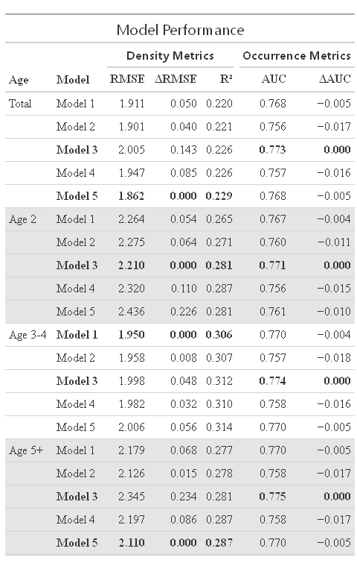
When predicting density, the best performing model formulations depended on age-group (Table 2). Age 5+ biomass density was best predicted by Model 5, showing a similar effect of temperature anomaly as with total hake but with a largely negative effect along the northern region (north of 47ºN) (Figure S2). Age 2 density was best predicted by Model 3, which incorporates a spatially stationary effect of the temperature anomaly at 250 meters depth. Age 3-4 density was best predicted by Model 1, which does not include temperature anomalies (Table 2). The density sub-models for ages 3-4 and 5+ show similar effects of shelf distance to those observed in the total hake density sub-model (Figure S1). In contrast, the age 2 density sub-model has the most positive effect of shelf distance occurring slightly inshore of the shelf break (Figure S1).

Table 2: Performance metrics of density and occurrence sub-models. Density model metrics are RMSE: the average RMSE over the past 7 years of the LFO-CV analysis, ΔRMSE: RMSE in comparison with the smallest value for each age class, and R-squared of the fully trained model fit. Occurrence sub-model metrics are AUC: average AUC over the past 7 years of the LFO-CV analysis and ΔAUC: AUC in comparison with the largest value for each age-class.

Forecast Analysis and Model Validation
The delta-models predicted large aggregations of hake biomass around the shelf break, with older hake residing further north than younger hake in 2024 (Figures 6 and 7). Model predictions for total hake biomass in 2024 were dominated by age 3+ hake, while age 2 hake had relatively little biomass concentrated in the southern region (below 44ºN) (Figures 6 and 7). Age 3-4 and 5+ models show predicted biomass hotspots in the southern region (below 47ºN), with age 5+ hake showing additional hotspots in the northern region (above 47ºN), particularly off the Strait of Juan de Fuca (Figures 6 and 7). Across age groups, the CV of the delta-model predictions was lowest along the shelf, where models predict large amounts of hake, and highest in regions distant from the shelf, both inshore and offshore (Figure 4).
The spatially explicit predicted distribution shift from 2023 to 2024 showed a largely cross-shelf pattern across age groups (Figure 4). Total hake biomass is predicted to decrease on the offshore side of the shelf break and in a narrow band along the coast of Washington and southern Vancouver Island (46 to 49ºN), and it is predicted to increase in a band along the shoreward side of the shelf break (Figure 4). Age 2 hake showed substantial predicted increases in biomass on the inshore of the shelf break below 48ºN and predicted decreases in pockets along the offshore side of the shelf break (Figure 4). Age 3-4 hake showed a similar pattern of change but with smaller increases in biomass on the inshore side of the shelf break (Figure 4). Age 5+ hake were expected to shift in a pattern similar to total hake but with larger decreases in biomass along the shore and smaller decreases offshore of the shelf break (Figure 4).
The regionally aggregated retrospective model analysis showed that the delta-GAMs had varying degrees of success in predicting the aggregated biomass in the two countries’ waters. The predictions for total hake in U.S. waters in 2012 and 2013 tracked observations closely (Figure 5a). However, accuracy declined during the warm years of 2015, 2017, and 2019, and improved again as temperatures returned to typical conditions. Across the retrospective period, the predictions for hake in Canadian waters were largely inaccurate (Figure 5a). Furthermore, models for all age groups failed to predict recent record low hake biomass in the Canadian waters (Figure 5). Finally, models predicted a slight decrease in hake in U.S. waters and in Canadian waters for all age groups from 2023 to 2024 (Figure 5).

Discussion
In this study, we used ocean temperature anomaly forecasts to develop predictive models for Pacific hake biomass across several age groups. Building on previous research that examined the impact of environmental drivers on hake presence and density separately, we developed delta-models that leveraged information on hake occurrence to increase the accuracy of density distribution predictions. We found that (1) temperature at depth slightly enhances forecasts of hake density and occurrence compared to using only spatial covariates, (2) the influence of temperature on biomass distributions varies across different life stages, and (3) an absence of a latitudinal gradient in the temperature effect diminishes the forecasts' utility in informing harvest allocations between the U.S. and Canada. These results indicate that temperature anomalies are useful predictors of hake biomass distributions, yet significant unexplained variability suggests the need for incorporating additional environmental variables and explore alternative modeling methods, such as boosted regression trees (BRTs). BRTs can capture complex, nonlinear relationships and high-order interactions without requiring prespecified functional forms, potentially offering greater predictive flexibility than GAMs (Elith et al., 2008).Further, these findings offer new evidence supporting a dominant cross-shelf effect of temperature anomaly on hake biomass.

Model Performance
Model selection indicated that the best models consistently favored temperature anomalies at a depth of 250 meters over 100 meters. This preference likely reflects the typical daytime schooling depth of hake, which ranges from 150 to 350 meters (Hamel et al., 2015; Phillips et al., 2023). The temperature ranges investigated lie within hake’s large preference range (Livingston & Bailey, 1985; Ressler et al., 2007), and likely a proxy of a more mechanistic driver of hake biomass distributions (Malick et al., 2020b). A leading hypothesis suggests that food availability, particularly krill, is a key driver of hake distribution (Bailey et al., 1982; Phillips et al., 2022, 2023; Ressler et al., 2007; Wells et al., 2023). Models using temperature anomalies at 250 meters consistently outperformed those using anomalies at 100 meters, likely because temperature anomalies at 250 meters are a better proxy for krill abundance, distribution, and their co-occurrence with hake (Phillips et al., 2022, 2023).
Hake occurrence
Our results indicate that the best occurrence sub-model across all age groups was Model 3, which included a spatially stationary effect of temperature anomaly. This suggests that temperature-linked processes likely influence hake presence similarly across age groups. In slightly warm conditions, the probability of hake presence is seen here to increase, suggesting that they tend to spread out under these conditions. High-temperature anomalies (> 0.4ºC) are associated with low presence and high biomass of total hake near and offshore of the shelf break. This indicates that hake may aggregate into dense schools offshore of the shelf break in these warmer conditions. This contrasts with previous studies, which found that both the abundance of krill and their co-occurrence with hake are observed to decrease in anomalously warm temperatures (Phillips et al., 2022, 2023). In these conditions, hake may spread out to seek alternative prey. Colder conditions have a slight negative to neutral effect on presence, suggesting that cold temperatures are not linked with any particular behavior that is linked to hake presence.
The occurrence sub-model selection results seem to deviate from past studies that have tested the ability of GAMs to predict total hake presence. Whereas Malick et al. (2020b) found that the spatially varying temperature model was better than the spatially stationary temperature model, our best model was informed by spatially stationary temperature. As with the density sub-models, the differences in model performance between studies could stem from the study design and the additional 7 years of training data (1998, 2001, 2003, 2005, 2007, 2021, and 2023) that we used in this study. Furthermore, these differences could be a result of updated hypotheses and related model formulations; Malick et al. (2020b) did not include models with both a spatially varying temperature (s(lat, lon) * T250Ano) and location term (s(lat, lon)). The inclusion of this location term likely accounted for variability that the spatially varying temperature term alone did not capture.
Hake density
The negative effects of temperature anomalies in the total and age 5+ density sub-models along the shelf (Figures 4 and S2) are consistent with previously observed negative effects of subsurface ocean temperature anomalies on krill occurrence and abundance in this region (Phillips et al., 2022, 2023). This supports the previously mentioned prey availability hypothesis (Bailey et al., 1982; Phillips et al., 2022, 2023; Ressler et al., 2007; Wells et al., 2023). The positive effect of temperature on hake distributions offshore of the shelf break may arise from the decrease in krill density on the shelf during warm temperatures (Phillips et al., 2022). In these warm conditions, in the absence of krill and with increased metabolic rates, hake may be leaving the shelf in search of alternative forms of food, such as forage fish (Phillips et al., 2023).
This study’s findings contrast with previous research, which found the effect of temperature anomalies on total hake density to have a gradual latitudinal gradient. For example, warmer temperatures correspond to less density along the Washington and Vancouver Island coasts and more density in the southern part of the study region (Malick et al., 2020a). By design, this previous study aimed to capture broad scale latitudinal (50x50 km resolution using 20 km binning of hake data) effects of temperature on hake density, and therefore it likely lacked the capacity to capture high-resolution cross-shelf patterns. Our results align with findings by Ware & McFarlane (1995) who observed positive correlations between ocean temperatures and hake biomass off the southern coast of Vancouver Island, which they attributed to the increased availability of food sources, specifically euphausiids and herring (Ware & McFarlane 1995). We found that the density sub-model incorporating spatially stationary temperature effects provided the best fit for age 2 hake. This indicated a peak effect of temperature anomaly at a small positive value (~0.3ºC) with diminishing effects on either side (Figure S8). This result does not provide support for the prey availability hypothesis. Immature hake, which are less piscivorous than their older counterparts, rely heavily on krill as their primary food source (Bailey et al., 1982; Livingston & Bailey, 1985). Since warmer temperatures are expected to reduce krill abundance and occurrence (Phillips et al., 2022), we would instead expect a negative link between warmer temperatures and age 2 hake density. Further, this finding contrasts previous studies, which found the effect of temperature on age 2 hake density to be spatially stationary but following a convex curve with a minimum near zero (Malick et al., 2020a). This difference is likely due to the limited scope of our study area, which only encompassed the northern region of the typical summertime distribution for age 2 hake, constrained by J-SCOPE's current spatial coverage (Figure S10).
We found that age 3-4 hake density was best predicted with Model 1, using only spatial variables (Table 2). Model 2, using a spatially stationary effect of temperature at 100m, was nearly as accurate in the LFO-CV analysis as Model 1, with each model outperforming the other during different anomalous years (i.e., 2015 and 2019, Figure S6). A previous study found that the density sub-model driven by latitude, longitude, and a spatially varying effect of temperature anomaly was best for age 3-4 (Malick et al., 2020a). Including shelf distance as a predictor in our models might have overshadowed the predictive power of temperature. This suggests that age 3-4 hake may exhibit higher site fidelity across a range of temperatures when compared to other age classes.

Forecast Evaluation
The hake spatial distribution predictions for 2024 generally match our current understanding of hake migration patterns across age classes, with older hake migrating further north than younger hake (Figures 6 and 7) (Dorn, 1995; Ressler et al., 2007). Model predictions exhibit larger relative errors far from the shelf break compared to along the shelf (Figure 4). This is likely due to the low confidence in the shelf break's effect on biomass in the density sub-model, which can be attributed to hake's fidelity to the shelf break (Figure S1).
The spatially explicit predicted change in biomass from 2023 to 2024 (Figure 4) did not align with previous studies and observations, which have indicated a dominant latitudinal effect of temperature on hake distributions (Dorn, 1995; Malick et al., 2020a; Ressler et al., 2007; Ware & McFarlane, 1995). Given that the temperature anomaly effects in the models for each age group do not show a strong latitudinal gradient, and the forecasted temperature anomaly at 250 meters depth for 2024 also lacks significant latitudinal variation (Figure 2), the primary changes in hake biomass are predominantly cross-shelf (Figure 4). To the best of our knowledge, the large-scale summertime cross-shelf distribution shift observed in this study has not been previously reported for hake, though similar cross-shelf shifts have been documented for other groundfish species along the U.S. West Coast under long-term climate projections (Li et al., 2019; Liu et al., 2023; Morley et al., 2018).
The model predictions of the hake in U.S. and Canadian waters did not consistently track the survey observations (Figure 8). The age 2 and age 3-4 hake models did not predict significant interannual changes in the biomass in these two regions (Figure 5). Since the delta-models for both age groups apply temperature effects through a spatially stationary function, and temperature is only included in the age 3-4 predictions through the occurrence sub-model, significant latitudinal variations in hake biomass could only be predicted if there were a corresponding latitudinal variation in temperature. On the other hand, the delta-models for the total and age 5+ age groups can predict larger latitudinal hake biomass change because their spatially varying effect of temperature has latitudinal variation. This difference in model design is a likely reason we see such small predicted changes over time for age 2 and age 3-4 hake and relatively larger changes for the total and age 5+ hake.
The years with the poorest predictive performance in our LFO-CV analysis were 2015, 2017, and 2019. Rather than indicating flaws in model design, the poor forecasting skill during these years likely reflects the fact that the included environmental predictors account for only 20–30% of the variation in biomass in our models. As such, a large proportion of the dynamics may be driven by unmodeled processes, which can reduce forecast skill—especially if those processes vary considerably across years.
The 2014-2016 marine heatwave known as “The Blob” was the most widespread and extreme of these events ever witnessed on the North American west coast, causing severe ecological effects and massive damage to fisheries (Free et al., 2023). Subsequent years, including 2017 and 2019, were also characterized by anomalously high temperatures at 250 meter depth throughout the study region (Figure S5). Although J-SCOPE projected similar warm conditions during these years, our delta-model outputs indicated substantial differences in predicted hake habitat extent (Figure S10).
Outside this extended warm period, forecast accuracy generally improved, though models still struggled to capture interannual variability consistent with observations (Figure 5). This complexity is further illustrated by the year 1998, the only other notably warm year prior to 2015, when temperature anomalies at 250 meters were largely confined to the continental slope and a strong biomass signal was observed across the region (Figure S5, S10). These contrasting distributional patterns during anomalously warm years suggest that temperature alone does not fully explain the environmental drivers of hake distribution. Additional, unmodeled factors are likely to play an important role, especially under extreme or novel conditions.

Implications, Caveats, and Future Directions
Our delta-models showed moderate accuracy in predicting latitudinal distribution shifts of hake across the U.S.–Canada border, but performance declined under novel ocean conditions, a pattern also observed for other species in the California Current (Muhling et al., 2020). Consequently, our confidence in these hake biomass forecasts is limited, and their current utility for informing international decisions on hake management and harvest may be restricted, as we expect more novel ocean conditions in the future. However, these models reveal new evidence of temperature-related cross-shelf shifts in the hake biomass distribution. Such shifts could impact the hake fishery coastwide if they occur on scales that limit the fishery's ability to access this stock. Specifically, these shifts could pose challenges if they result in spatial overlap with non-target fish species or conflict with other ocean uses. Future studies should look deeper into the cross-shelf effects of environmental drivers on hake distributions, especially around regions sited for offshore wind energy development, as the fisheries in these areas could be impacted by the combined effects of spatial restrictions and spatial distribution shifts of marine species.
While our models prioritized temperature due to its established mechanistic relationship with hake distributions, results suggest that temperature alone is insufficient to fully capture hake movement patterns. Other explanatory variables have been previously considered, such as krill biomass (Phillips et al., 2023) and the California Undercurrent velocity (Agostini et al., 2006, 2008; Malick et al., 2024), whereas factors like dissolved oxygen remain underexplored. While dissolved oxygen data were available, we prioritized temperature as our primary predictor based on its established mechanistic relationship with hake distribution. Other potential predictors, such as prey distributions, remained constrained by limited spatiotemporal coverage in forecast products. Our modeling framework can be readily adapted to incorporate additional environmental drivers, such as improved model outputs of ocean temperature, dissolved oxygen concentration at depth, and prey abundance (e.g., krill distributions). Including these variables could enhance predictive accuracy and extend the spatial and temporal resolution of hake distribution forecasts.
Several aspects of our data and modeling framework limit the accuracy of summertime hake distribution forecasts. First, temporal mismatches exist between the timing of the hake survey, which varies by weeks among years, and the August-averaged temperature anomalies from J-SCOPE. Second, we were unable to incorporate current-year age-group biomass as a predictor due to high collinearity with the response variable. Lastly, our models represent a snapshot in time and do not account for environmental conditions experienced during hake migration, which could influence summer distributions.
Despite these constraints, this work represents a significant step toward operational forecasting of hake distributions. Future efforts may benefit from integrating dynamic predictors, such as migration pathway conditions, or incorporating expected biomass through methods less prone to multicollinearity. Extending these models to account for lagged ecological drivers or cumulative effects across seasons could provide a more holistic understanding of hake habitat use. This modeling framework, developed in conjunction with the foundational work of Malick et al., offers exciting opportunities to better anticipate distribution shifts in this ecologically and economically important species.

Acknowledgements
We thank the Fisheries Engineering and Acoustic Technologies Team for collecting the hake biomass data used in this analysis. We also thank Emily Norton for developing and providing the J-SCOPE model outputs, and Kristin Marshall for her essential contributions to the writing of this manuscript.

References
Agostini, V. N., Francis, R. C., Hollowed, A. B., Pierce, S. D., Wilson, C., & Hendrix, A. N. (2006). The relationship between Pacific hake ( Merluccius productus ) distribution and poleward subsurface flow in the California Current System. Canadian Journal of Fisheries and Aquatic Sciences, 63(12), 2648–2659. https://doi.org/10.1139/f06-139
Agostini, V. N., Hendrix, A. N., Hollowed, A. B., Wilson, C. D., Pierce, S. D., & Francis, R. C. (2008). Climate–ocean variability and Pacific hake: A geostatistical modeling approach. Journal of Marine Systems, 71(3), 237–248. https://doi.org/10.1016/j.jmarsys.2007.01.010
Agreement Between the Government of the United States of America and the Government of Canada on Pacific Hake/Whiting (The “Agreement”), Senate 108th Congress 2d Session, Treaty Doc. 108-24 (2004).
Bacheler, N., Bailey, K., Ciannelli, L., Bartolino, V., & Chan, K. (2009). Density-dependent, landscape, and climate effects on spawning distribution of walleye pollock Theragra chalcogramma. Marine Ecology Progress Series, 391, 1–12. https://doi.org/10.3354/meps08259
Bacheler, N. M., Ciannelli, L., Bailey, K. M., & Bartolino, V. (2012). Do walleye pollock exhibit flexibility in where or when they spawn based on variability in water temperature? Deep Sea Research Part II: Topical Studies in Oceanography, 65–70, 208–216. https://doi.org/10.1016/j.dsr2.2012.02.001
Bailey, K. M., Francis, R. C., & Stevens, P. R. (1982). The Life History and Fishery of Pacific Whiting, Merluccius Productus.
Barnes, C. L., Essington, T. E., Pirtle, J. L., Rooper, C. N., Laman, E. A., Holsman, K. K., Aydin, K. Y., & Thorson, J. T. (2022). Climate-informed models benefit hindcasting but present challenges when forecasting species–habitat associations. Ecography, 2022(10), e06189. https://doi.org/10.1111/ecog.06189
Bartolino, V., Ciannelli, L., Bacheler, N. M., & Chan, K.-S. (2011). Ontogenetic and sex-specific differences in density-dependent habitat selection of a marine fish population. Ecology, 92(1), 189–200. https://doi.org/10.1890/09-1129.1
Cheung, W. W. L., Lam, V. W. Y., Sarmiento, J. L., Kearney, K., Watson, R., Zeller, D., & Pauly, D. (2010). Large-scale redistribution of maximum fisheries catch potential in the global ocean under climate change. Global Change Biology, 16(1), 24–35. https://doi.org/10.1111/j.1365-2486.2009.01995.x
Ciannelli, L., Bartolino, V., & Chan, K.-S. (2012). Non-additive and non-stationary properties in the spatial distribution of a large marine fish population. Proceedings of the Royal Society B: Biological Sciences, 279(1743), 3635–3642. https://doi.org/10.1098/rspb.2012.0849
Dorn, M. W. (1995). The Effects of Age Composition and Oceanographic Conditions on the Annual Migration of Pacific Whiting, Merluccius Productus.
Fleischer, G. W., Cooke, K. D., Ressler, P. H., & Thomas, R. E. (2005). NOAA Technical Memorandum NMFS-NWFSC-94. The 2005 Integrated Acoustic and Trawl Survey of Pacific Hake, Merluccius productus, in U.S. and Canadian Waters off the Pacific Coast.
Free, C. M., Anderson, S. C., Hellmers, E. A., Muhling, B. A., Navarro, M. O., Richerson, K., Rogers, L. A., Satterthwaite, W. H., Thompson, A. R., Burt, J. M., Gaines, S. D., Marshall, K. N., White, J. W., & Bellquist, L. F. (2023). Impact of the 2014–2016 marine heatwave on US and Canada West Coast fisheries: Surprises and lessons from key case studies. Fish & Fisheries, 24(4), 652–674. https://doi.org/10.1111/faf.12753
Gordó-Vilaseca, C., Costello, M. J., Coll, M., Jüterbock, A., Reiss, H., & Stephenson, F. (2024). Future trends of marine fish biomass distributions from the North Sea to the Barents Sea. Nature Communications, 15(1), 5637. https://doi.org/10.1038/s41467-024-49911-9
Grandin, C. J., Johnson, K. F., Edwards, A. M., & Berger, A. M. (2024). Status of the Pacific Hake (whiting) stock in U.S. and Canadian waters in 2024. Prepared by the Joint Technical Committee of the U.S. and Canada Pacific Hake/Whiting Agreement. National Marine Fisheries Service and Fisheries and Oceans Canada.
Greenan, B. J. W., Shackell, N. L., Ferguson, K., Greyson, P., Cogswell, A., Brickman, D., Wang, Z., Cook, A., Brennan, C. E., & Saba, V. S. (2019). Climate Change Vulnerability of American Lobster Fishing Communities in Atlantic Canada. Frontiers in Marine Science, 6. https://doi.org/10.3389/fmars.2019.00579
Grüss, A., Drexler, M., & Ainsworth, C. H. (2014). Using delta generalized additive models to produce distribution maps for spatially explicit ecosystem models. Fisheries Research, 159, 11–24. https://doi.org/10.1016/j.fishres.2014.05.005
Hamel, O. S., Ressler, P. H., Thomas, R. E., Waldeck, D. A., Hicks, A. C., Holmes, J. A., & Fleischer, G. W. (2015). Biology, fisheries, assessment and management of Pacific hake (Merluccius productus). In Hakes: Biology and Exploitation. John Wiley & Sons, Incorporated. http://ebookcentral.proquest.com/lib/osu/detail.action?docID=4036357
Hastie, T. J. (1992). Generalized Additive Models. In Statistical Models in S. Routledge.
Hayes, D. B., Brodziak, J. K. T., & O’Gorman, J. B. (1995). Efficiency and bias of estimators and sampling designs for determining length-weight relationships of fish. Canadian Journal of Fisheries and Aquatic Sciences, 52(1), 84–92. https://doi.org/10.1139/f95-008
Hazen, E. L., Scales, K. L., Maxwell, S. M., Briscoe, D. K., Welch, H., Bograd, S. J., Bailey, H., Benson, S. R., Eguchi, T., Dewar, H., Kohin, S., Costa, D. P., Crowder, L. B., & Lewison, R. L. (2018). A dynamic ocean management tool to reduce bycatch and support sustainable fisheries. Science Advances, 4(5), eaar3001. https://doi.org/10.1126/sciadv.aar3001
Hicks, A. C., Taylor, N., Grandin, C., Taylor, I. G., & Cox, S. (2013). Status of the Pacific hake (whiting) stock in U.S. and Canadian waters in 2013. https://www.pcouncil.org/documents/2013/03/status-of-the-pacific-hake-whiting-stock-in-u-s-and-canadian-waters-in-2013-final-document-march-4-2013.pdf/
Hobday, A. J., Hartog, J. R., Spillman, C. M., & Alves, O. (2011). Seasonal forecasting of tuna habitat for dynamic spatial management. Canadian Journal of Fisheries and Aquatic Sciences, 68(5), 898–911. https://doi.org/10.1139/f2011-031
Howard, R. A., Ciannelli, L., Waldo Wakefield, W., & Fewings, M. R. (2021). The effects of climate, oceanography, and habitat on the distribution and abundance of northern California Current continental shelf groundfishes. Fisheries Oceanography, 30(6), 707–725. https://doi.org/10.1111/fog.12553
Kaplan, I. C., Williams, G. D., Bond, N. A., Hermann, A. J., & Siedlecki, S. A. (2016). Cloudy with a chance of sardines: Forecasting sardine distributions using regional climate models. Fisheries Oceanography, 25(1), 15–27. https://doi.org/10.1111/fog.12131
Li, L., Hollowed, A. B., Cokelet, E. D., Barbeaux, S. J., Bond, N. A., Keller, A. A., King, J. R., McClure, M. M., Palsson, W. A., Stabeno, P. J., & Yang, Q. (2019). Subregional differences in groundfish distributional responses to anomalous ocean bottom temperatures in the northeast Pacific. Global Change Biology, 25(8), 2560–2575. https://doi.org/10.1111/gcb.14676
Liu, O. R., Ward, E. J., Anderson, S. C., Andrews, K. S., Barnett, L. A. K., Brodie, S., Carroll, G., Fiechter, J., Haltuch, M. A., Harvey, C. J., Hazen, E. L., Hernvann, P.-Y., Jacox, M., Kaplan, I. C., Matson, S., Norman, K., Pozo Buil, M., Selden, R. L., Shelton, A., & Samhouri, J. F. (2023). Species redistribution creates unequal outcomes for multispecies fisheries under projected climate change. Science Advances, 9(33), eadg5468. https://doi.org/10.1126/sciadv.adg5468
Livingston, P. A., & Bailey, K. M. (1985). Trophic role of the Pacific whiting, Merluccius productus. Marine Fisheries Review, 47.
Mackas, D. L., Kieser, R., Saunders, M., Yelland, D. R., Brown, R. M., & Moore, D. F. (1997). Aggregation of euphausiids and Pacific hake (Merluccius productus) along the outer continental shelf off Vancouver Island. Canadian Journal of Fisheries and Aquatic Sciences, 54(9), 2080–2096. https://doi.org/10.1139/f97-113
Malick, Hunsicker, M., Haltuch, M., Parker-Stetter, S., Berger, A., & Marshall, K. (2020a). Relationships between temperature and Pacific hake distribution vary across latitude and life-history stage. Marine Ecology Progress Series, 639, 185–197. https://doi.org/10.3354/meps13286
Malick, M. J., Siedlecki, S. A., Norton, E. L., Kaplan, I. C., Haltuch, M. A., Hunsicker, M. E., Parker-Stetter, S. L., Marshall, K. N., Berger, A. M., Hermann, A. J., Bond, N. A., & Gauthier, S. (2020b). Environmentally Driven Seasonal Forecasts of Pacific Hake Distribution. Frontiers in Marine Science, 7. https://www.frontiersin.org/articles/10.3389/fmars.2020.578490
Malick, M. J., Hunsicker, M. E., Haltuch, M. A., Parker-Stetter, S. L., Marshall, K. N., Pohl, J. E., Berger, A. M., Siedlecki, S. A., Gauthier, S., & Hermann, A. J. (2024). Spatially varying effects of the California Undercurrent on Pacific hake distribution: Canadian Journal of Fisheries & Aquatic Sciences. Canadian Journal of Fisheries & Aquatic Sciences, 81(2), 154–165. https://doi.org/10.1139/cjfas-2023-0202
Morley, J. W., Selden, R. L., Latour, R. J., Frölicher, T. L., Seagraves, R. J., & Pinsky, M. L. (2018). Projecting shifts in thermal habitat for 686 species on the North American continental shelf. PLOS ONE, 13(5), e0196127. https://doi.org/10.1371/journal.pone.0196127
Muhling, B. A., Brodie, S., Smith, J. A., Tommasi, D., Gaitan, C. F., Hazen, E. L., Jacox, M. G., Auth, T. D., & Brodeur, R. D. (2020). Predictability of Species Distributions Deteriorates Under Novel Environmental Conditions in the California Current System. Frontiers in Marine Science, 7, 589. https://doi.org/10.3389/fmars.2020.00589
Palacios-Abrantes, J., Frölicher, T. L., Reygondeau, G., Sumaila, U. R., Tagliabue, A., Wabnitz, C. C. C., & Cheung, W. W. L. (2022). Timing and magnitude of climate-driven range shifts in transboundary fish stocks challenge their management. Global Change Biology, 28(7), 2312–2326. https://doi.org/10.1111/gcb.16058
Perry, A. L., Low, P. J., Ellis, J. R., & Reynolds, J. D. (2005). Climate Change and Distribution Shifts in Marine Fishes. Science, 308(5730), 1912–1915. https://doi.org/10.1126/science.1111322
Phillips, E. M., Chu, D., Gauthier, S., Parker-Stetter, S. L., Shelton, A. O., & Thomas, R. E. (2022). Spatiotemporal variability of euphausiids in the California Current Ecosystem: Insights from a recently developed time series. ICES Journal of Marine Science, 79(4), 1312–1326. https://doi.org/10.1093/icesjms/fsac055
Phillips, E. M., Malick, M. J., Gauthier, S., Haltuch, M. A., Hunsicker, M. E., Parker-Stetter, S. L., & Thomas, R. E. (2023). The influence of temperature on Pacific hake co-occurrence with euphausiids in the California Current Ecosystem. Fisheries Oceanography, 32(3), 267–279. https://doi.org/10.1111/fog.12628
Pinsky, M. L., & Fogarty, M. (2012). Lagged social-ecological responses to climate and range shifts in fisheries. Climatic Change, 115(3), 883–891. https://doi.org/10.1007/s10584-012-0599-x
Pinsky, M. L., Selden, R. L., & Kitchel, Z. J. (2020). Climate-Driven Shifts in Marine Species Ranges: Scaling from Organisms to Communities. Annual Review of Marine Science, 12, 153-179.
Ressler, P. H., Holmes, J. A., Fleischer, G. W., Thomas, R. E., & Cooke, K. C. (2007). Paciﬁc Hake, Merluccius productus, Autecology: A Timely Review. Marine Fisheries Review.
Rooper, C. N., Ortiz, I., Hermann, A. J., Laman, N., Cheng, W., Kearney, K., & Aydin, K. (2021). Predicted shifts of groundfish distribution in the Eastern Bering Sea under climate change, with implications for fish populations and fisheries management. ICES Journal of Marine Science, 78(1), 220–234. https://doi.org/10.1093/icesjms/fsaa215
Selden, R. L., Thorson, J. T., Samhouri, J. F., Bograd, S. J., Brodie, S., Carroll, G., Haltuch, M. A., Hazen, E. L., Holsman, K. K., Pinsky, M. L., Tolimieri, N., & Willis-Norton, E. (2020). Coupled changes in biomass and distribution drive trends in availability of fish stocks to US West Coast ports. ICES Journal of Marine Science, 77(1), 188–199. https://doi.org/10.1093/icesjms/fsz211
Shelton, A. O., Hunsicker, M. E., Ward, E. J., Feist, B. E., Blake, R., Ward, C. L., Williams, B. C., Duffy-Anderson, J. T., Hollowed, A. B., & Haynie, A. C. (2018). Spatio-temporal models reveal subtle changes to demersal communities following the Exxon Valdez oil spill. ICES Journal of Marine Science, 75(1), 287–297. https://doi.org/10.1093/icesjms/fsx079
Siedlecki, S. A., Alin, S. R., Norton, E. L., Bond, N. A., & Hermann, A. J. (2023). Can Seasonal Forecasts of Ocean Conditions Aid Fishery Managers? Experiences from 10 Years of J-SCOPE | Oceanography. https://tos.org/oceanography/article/can-seasonal-forecasts-of-ocean-conditions-aid-fishery-managers-experiences-from-10-years-of-j-scope
Siedlecki, S. A., Kaplan, I. C., Hermann, A. J., Nguyen, T. T., Bond, N. A., Newton, J. A., Williams, G. D., Peterson, W. T., Alin, S. R., & Feely, R. A. (2016). Experiments with Seasonal Forecasts of ocean conditions for the Northern region of the California Current upwelling system. Scientific Reports, 6(1), 27203. https://doi.org/10.1038/srep27203
Stock, B. C., Ward, E. J., Eguchi, T., Jannot, J. E., Thorson, J. T., Feist, B. E., & Semmens, B. X. (2020). Comparing predictions of fisheries bycatch using multiple spatiotemporal species distribution model frameworks. Canadian Journal of Fisheries and Aquatic Sciences, 77(1), 146–163. https://doi.org/10.1139/cjfas-2018-0281
Thorson, J. T., Shelton, A. O., Ward, E. J., & Skaug, H. J. (2015). Geostatistical delta-generalized linear mixed models improve precision for estimated abundance indices for West Coast groundfishes. ICES Journal of Marine Science, 72(5), 1297–1310. https://doi.org/10.1093/icesjms/fsu243
Thorson, J. T. (2018). Three problems with the conventional delta-model for biomass sampling data, and a computationally efficient alternative. Canadian Journal of Fisheries and Aquatic Sciences, 75(9), 1369–1382. https://doi.org/10.1139/cjfas-2017-0266
Tommasi, D., Stock, C. A., Alexander, M. A., Yang, X., Rosati, A., & Vecchi, G. A. (2017). Multi-Annual Climate Predictions for Fisheries: An Assessment of Skill of Sea Surface Temperature Forecasts for Large Marine Ecosystems. Frontiers in Marine Science, 4, 201. https://doi.org/10.3389/fmars.2017.00201
Ware, D. M., & McFarlane, G. (1995). Climate induced changes in hake abundance and pelagic community interactions in the Vancouver Island upwelling system (pp. 509–521).
Wells, B., Santora, J., Bizzarro, J., Billings, A., Brodeur, R., Daly, E., Field, J., Richerson, K., & Thorson, J. (2023). Trophoscapes of predatory fish reveal biogeographic structuring of spatial dietary overlap and inform fisheries bycatch patterns. Marine Ecology Progress Series, SPF2. https://doi.org/10.3354/meps14319
Wood, S. N. (2017). Generalized Additive Models: An Introduction with R, Second Edition (2nd ed.). Chapman and Hall/CRC. https://doi.org/10.1201/9781315370279

Main text figures:

Figure 0: Hake migration pattern

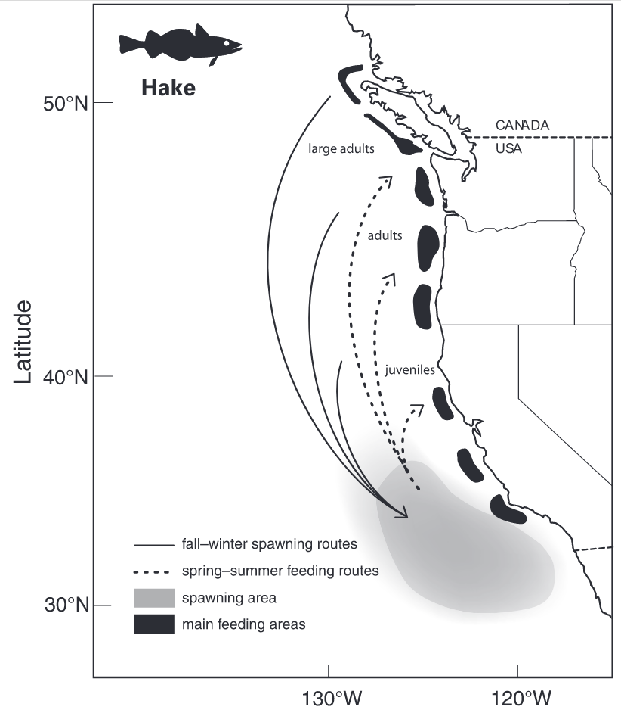

Figure 0: Representation of the coastal hake population’s seasonal migration pattern (Agostini et al. 2006).

Fig. 1: Hake observation data
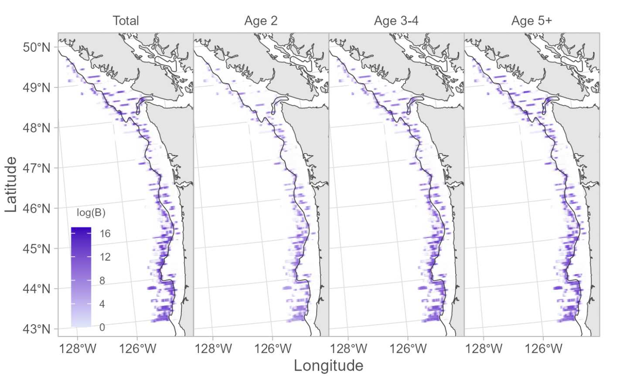
Figure 1: Spatial distribution of Pacific hake survey biomass observations (2012-2022) along the U.S. and Canadian West Coast. Data are shown in logarithmic scale (logₑ(B)) by age group: total biomass, age 2, age 3-4, and age 5+. Purple intensity indicates biomass density, with darker shades representing higher values.

Fig. 2: Temperature anomaly forecasts
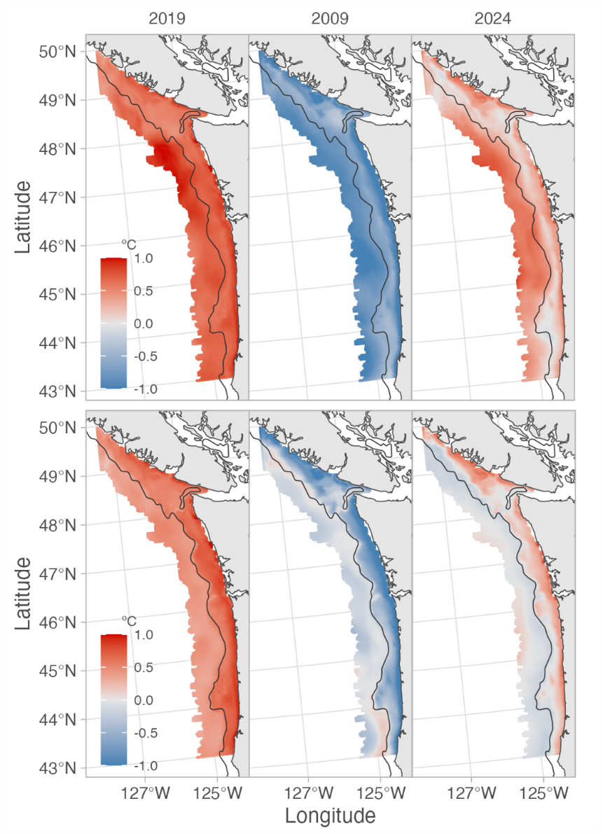

Figure 2: J-SCOPE temperature anomaly forecasts (°C) at 100 meter depth (top row) and 250 meter depth (bottom row) along the U.S. and Canadian West Coast. Maps show temperature anomalies for a warm year (2019, left column), a cold year (2009, middle column), and the 2024 forecast (right column). Red colors indicate positive anomalies (warmer than average) and blue colors indicate negative anomalies (cooler than average).

Fig. 3: Partial effects plots for total hake models.
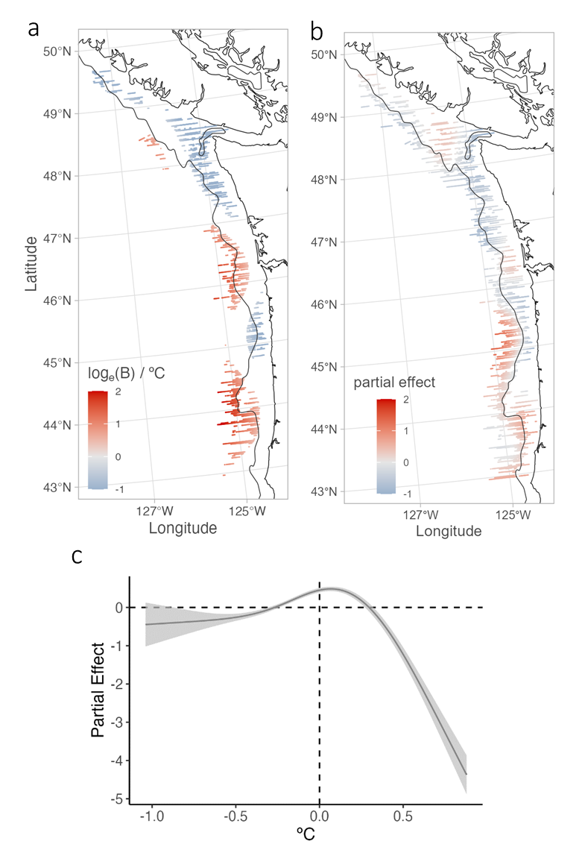

Figure 3: Partial effects plots for total hake sub-models. (a) Spatially varying effect of temperature anomaly at 250 meter depth on hake density in the density sub-model, with color indicating the change in log biomass density (logₑ(B)) per °C. (b) Partial effect of the smooth bivariate function of latitude and longitude on hake density in the density sub-model, with the 200 meter isobath shown in black. (c) Spatially stationary (global) effect of temperature anomaly at 250 meter depth on hake occurrence probability in the occurrence sub-model, with gray shading representing the 95% confidence interval.

Fig. 4: Hake biomass forecast, forecast CV, and forecasted distribution shift from 2023 to 2024
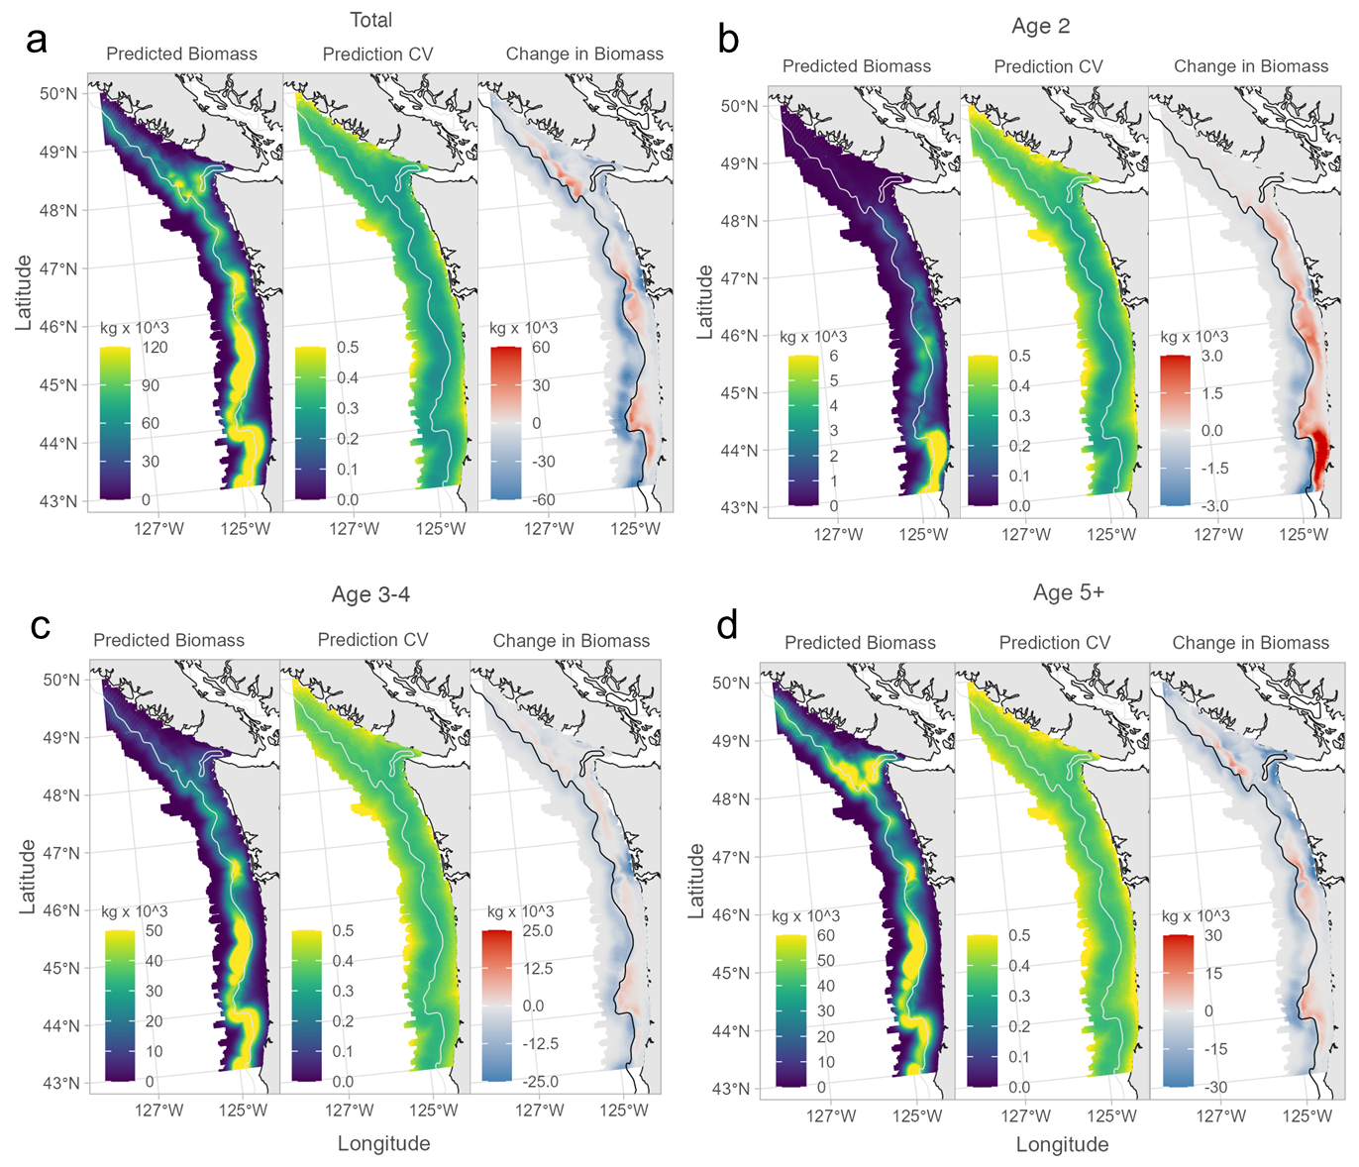
Figure 4: Spatial distribution of delta-model hake biomass forecasts for 2024 (left column), forecast coefficient of variation (CV) (middle column), and forecasted biomass change from 2023 to 2024 (right column) for a) total biomass, b) age 2, c) age 3-4, and d) age 5+ age classes. Changes in biomass are only shown where the 95% confidence interval did not include zero (i.e., statistically significant changes).

Fig. 5: Time series of forecasted and observed hake biomass in the U.S. and Canada.
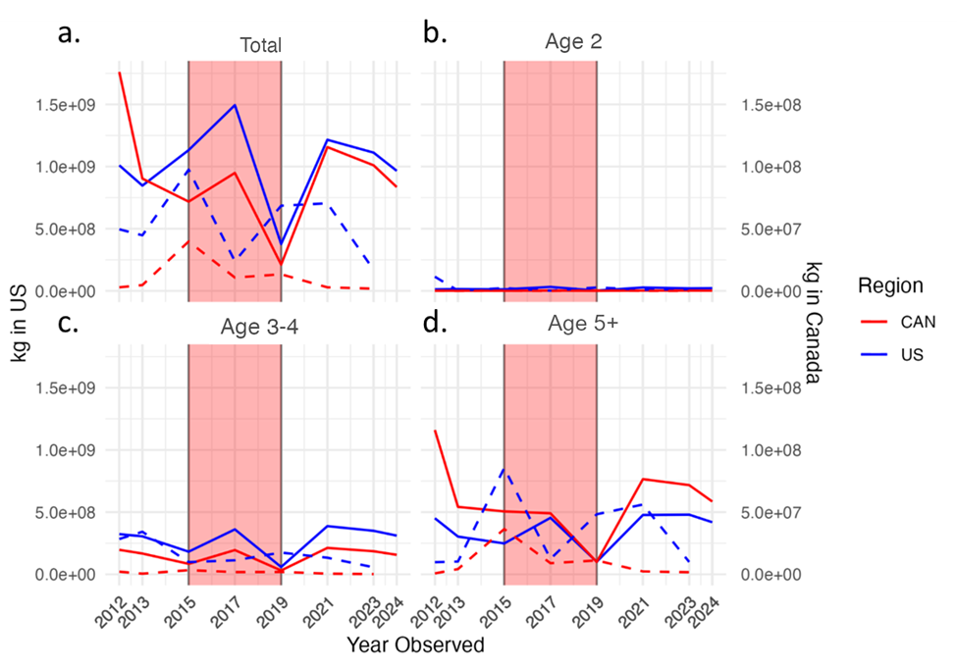
Figure 5: Time series of hake biomass predicted using the best trained delta-model (solid lines) and observed from hake surveys (dashed lines) for (a) total biomass, (b) age 2, (c) age 3-4, and (d) age 5+ in the U.S. (blue) and Canada (red) from 2012-2024. Predicted biomasses for 2024 are shown at the right end of the solid lines. Anomalously warm years (2015, 2017, and 2019) are highlighted with red shading.

Supplemental Information
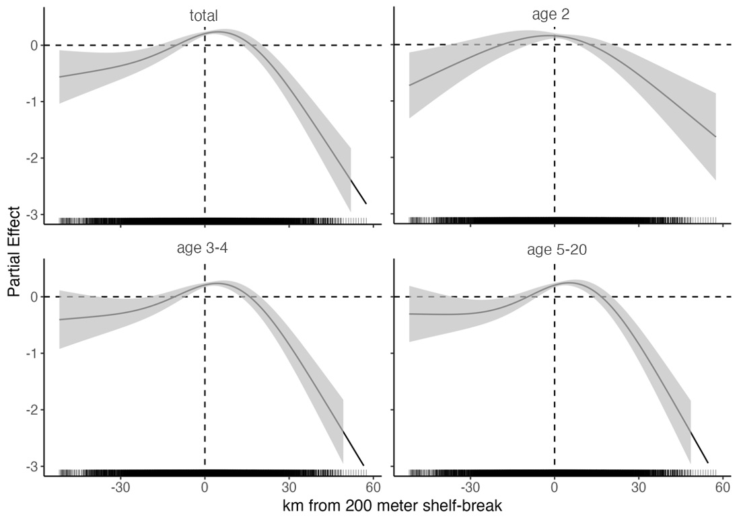
Figure S1: Effect of shelf distance on biomass density for total (top left), age 2 (top right), age 3-4 (bottom left), and age 5+ (bottom right) hake for Models 5, 3, 1, and 5 respectively.

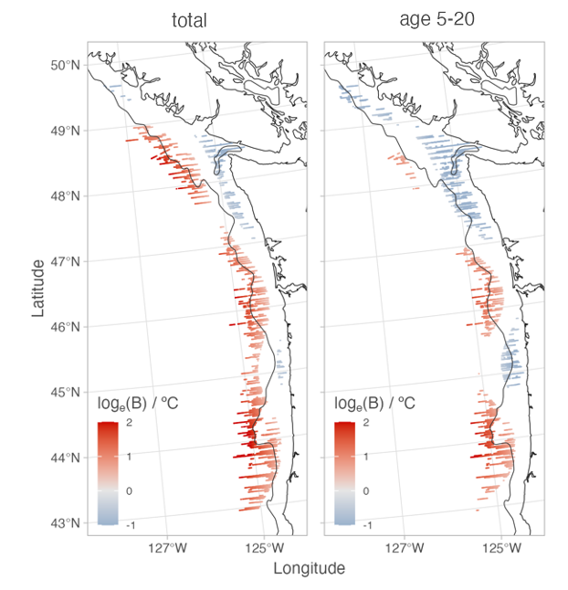

Figure S2: Variable coefficient of temperature anomaly at 250 meter depth for biomass density sub-models of total (left) and age 5+ (right) hake in Model 5 with all non-significant coefficients removed.

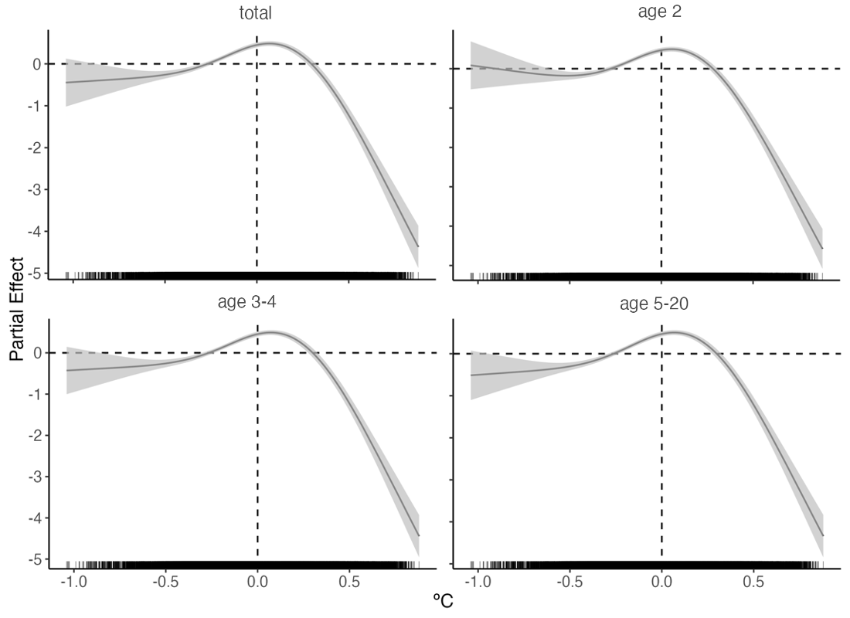

Figure S3: Spatially stationary effect of temperature anomaly at 250 meter depth on occurrence of total (top left), age 2 (top right), age 3-4 (bottom left), and age 5+ (bottom right) hake in Model 3.
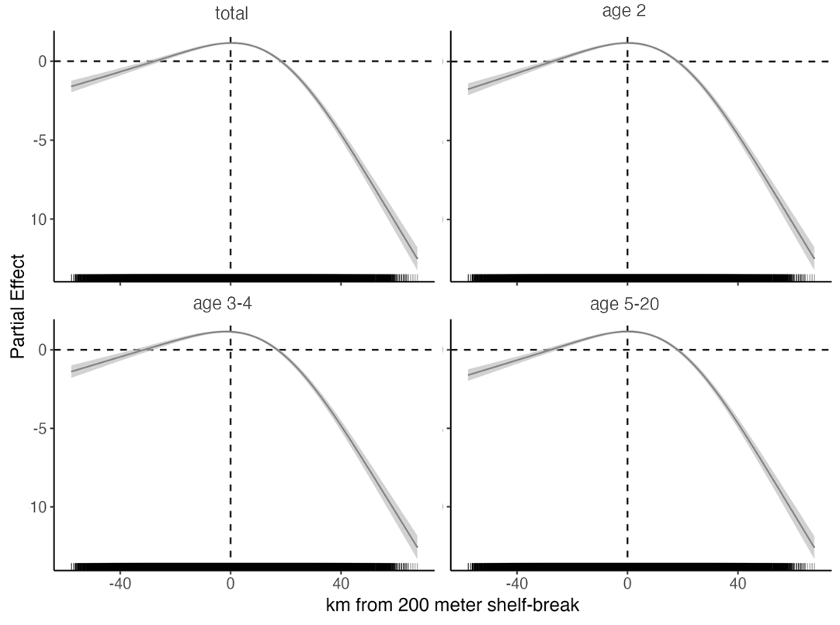

Figure S4: Effect of shelf distance on occurrence of total (top left), age 2 (top right), age 3-4 (bottom left), and age 5+ (bottom right) hake in Model 3.

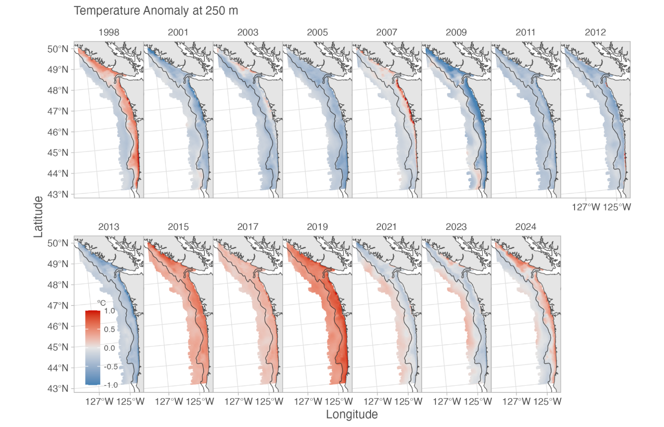

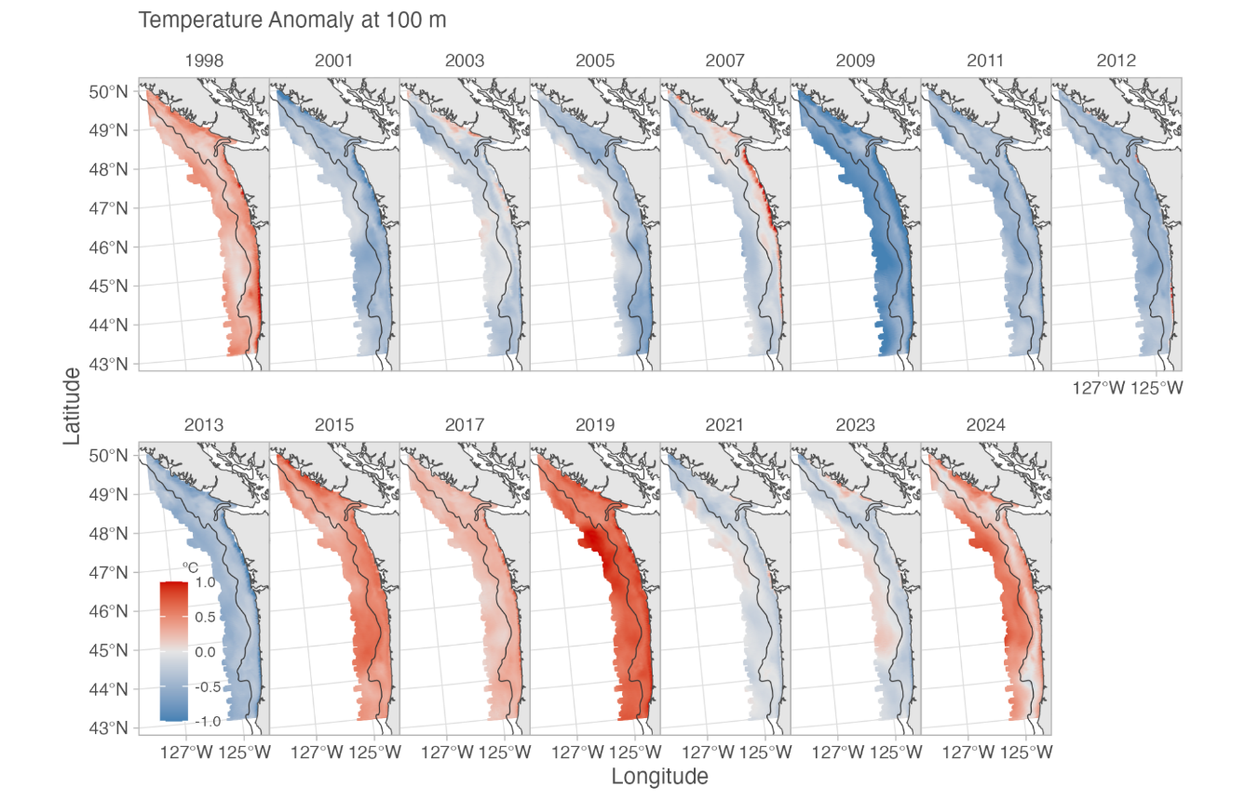

Figure S5: J-SCOPE temperature anomaly forecasts for all years investigated in this study. Temperature at 250 meter depth (top) and temperature at 100 meter depth (bottom).

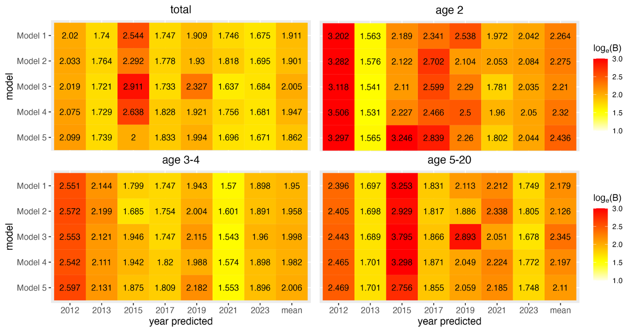
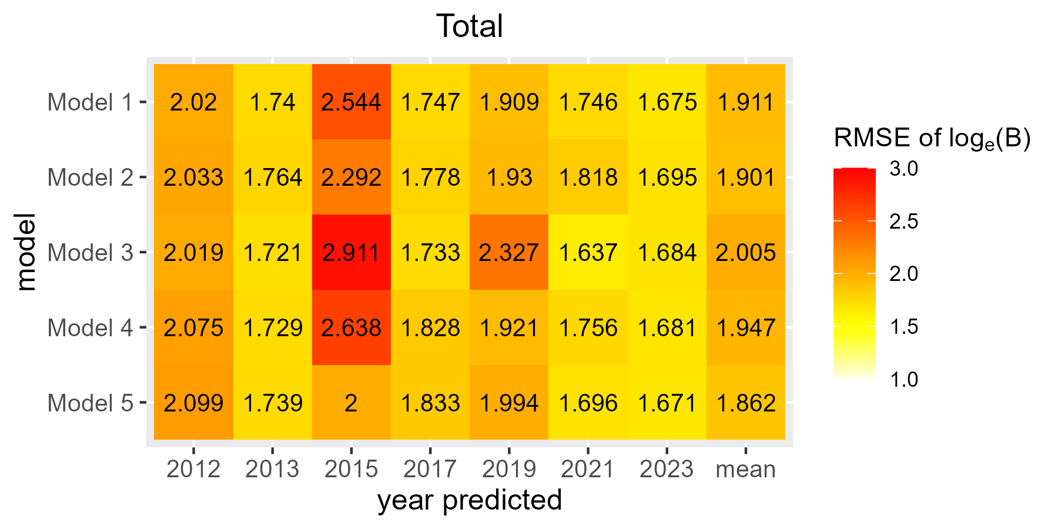

Figure S6: Leave-future-out cross-validation (LFO-CV) model selection results for density sub-models for total (top left), age 2 (top right), age 3-4 (bottom left), and age 5+ (bottom right) hake. Each column shows the prediction’s root mean square error (RMSE) from the log biomass observed on the hake survey for the year labeled. The final column shows the average RMSE for each model across the years shown.

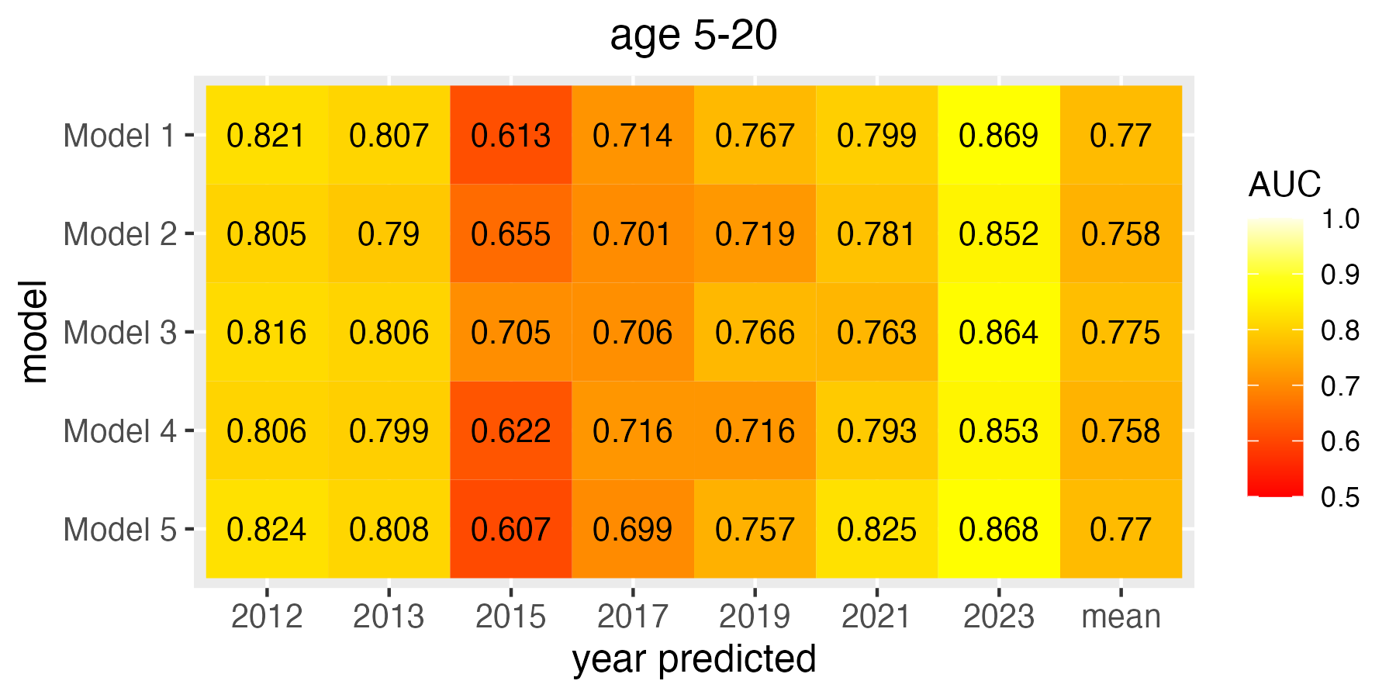
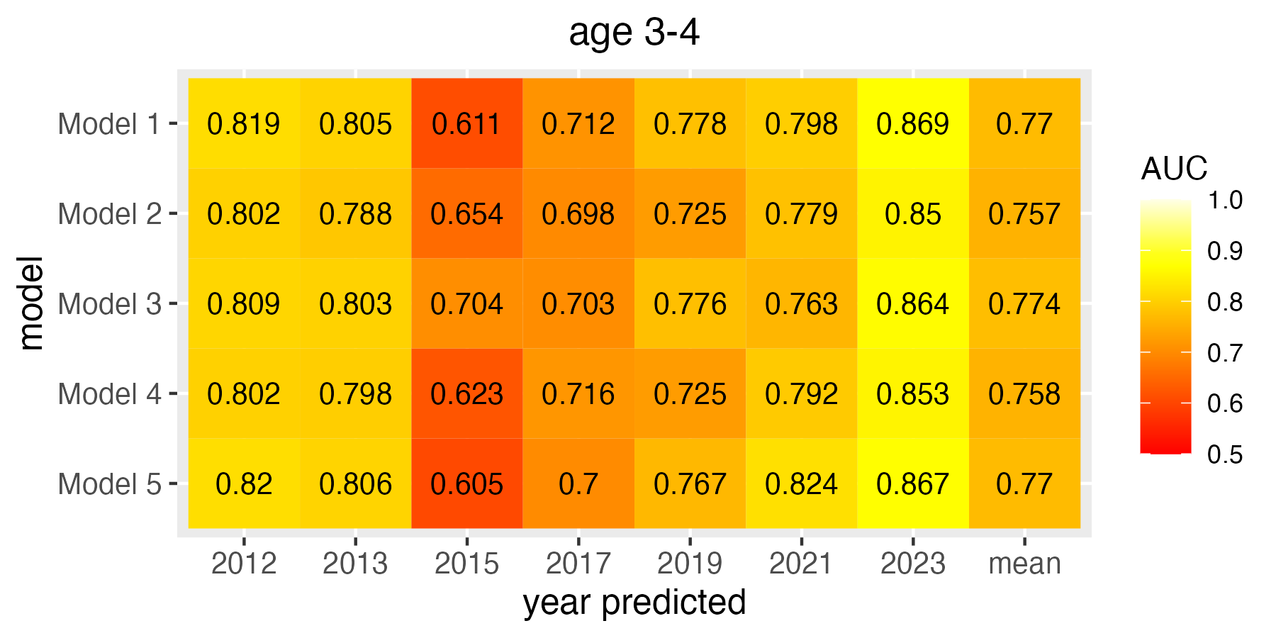
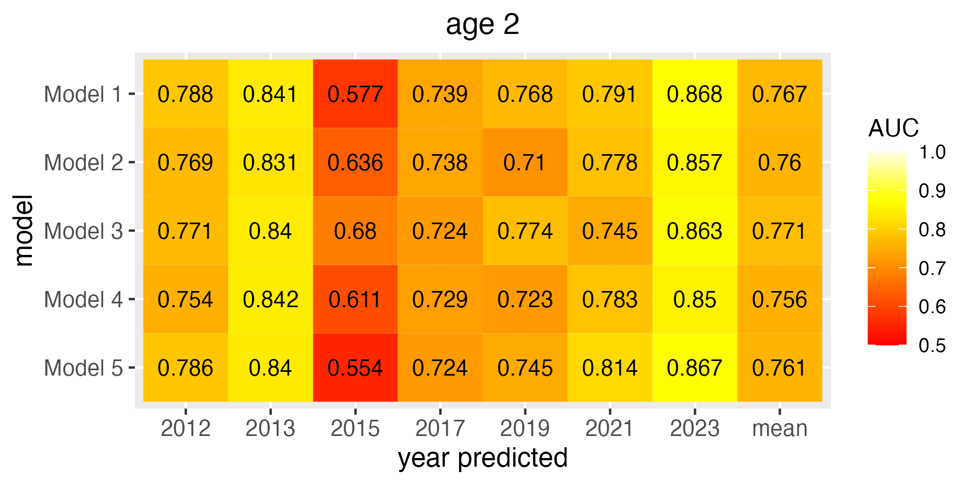
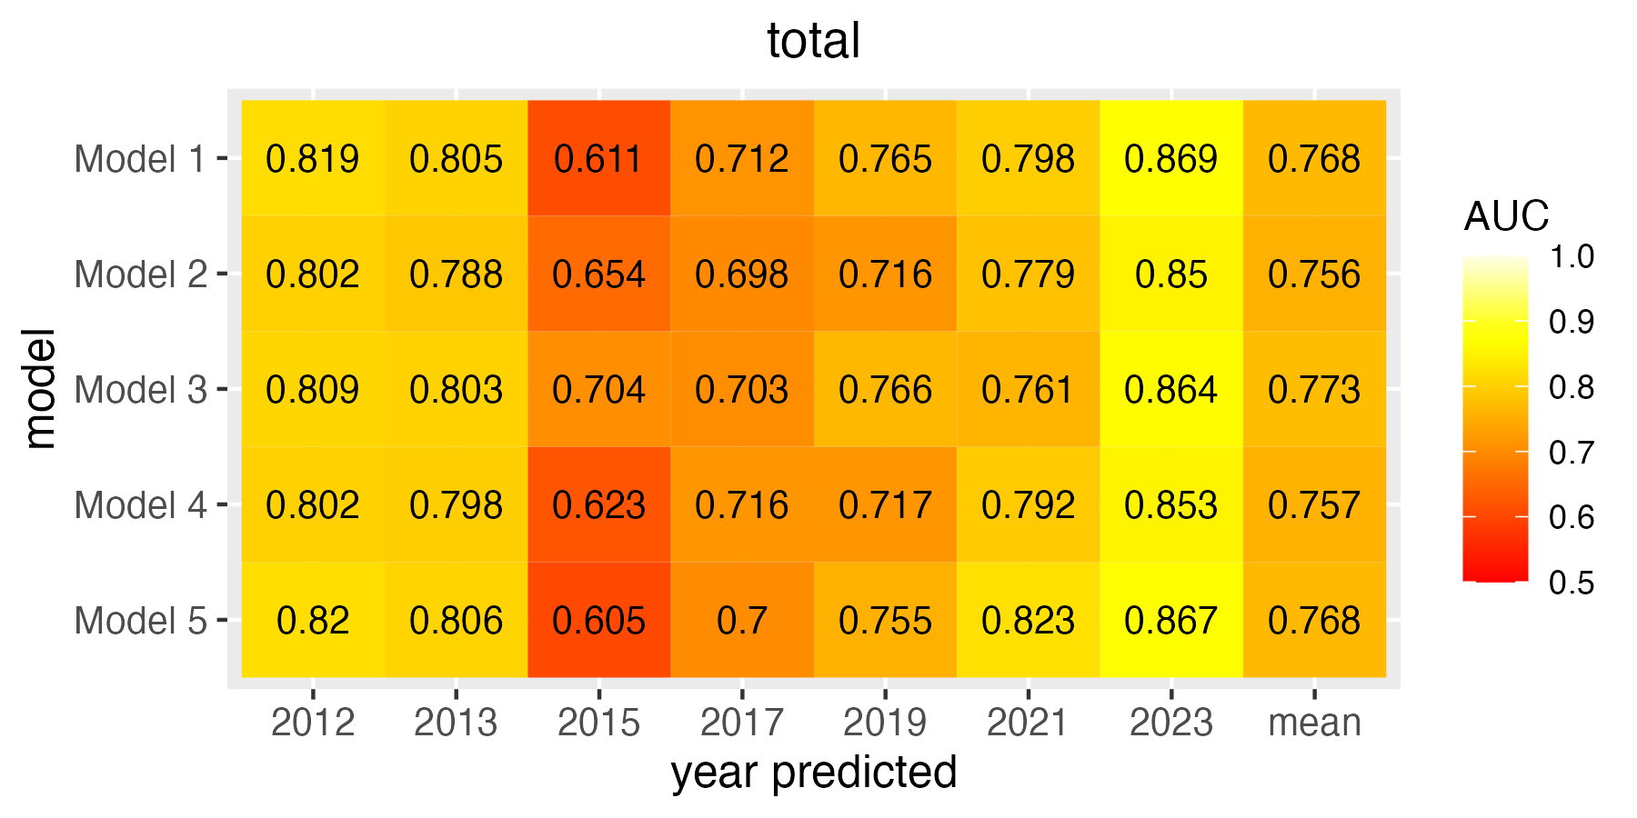

Figure S7: Leave-future-out cross-validation (LFO-CV) model selection results for occurrence sub-models for total (top left), age 2 (top right), age 3-4 (bottom left), and age 5+ (bottom right) hake. Each column shows the prediction’s area under the curve (AUC) as compared to the survey data. The final column shows the average AUC for each model across the years shown.

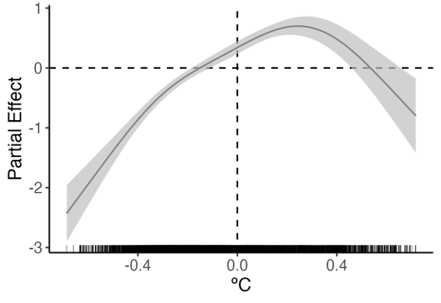

Figure S8: Spatially stationary effect of temperature anomaly at 250 meter depth on age 2 hake biomass density in Model 3.
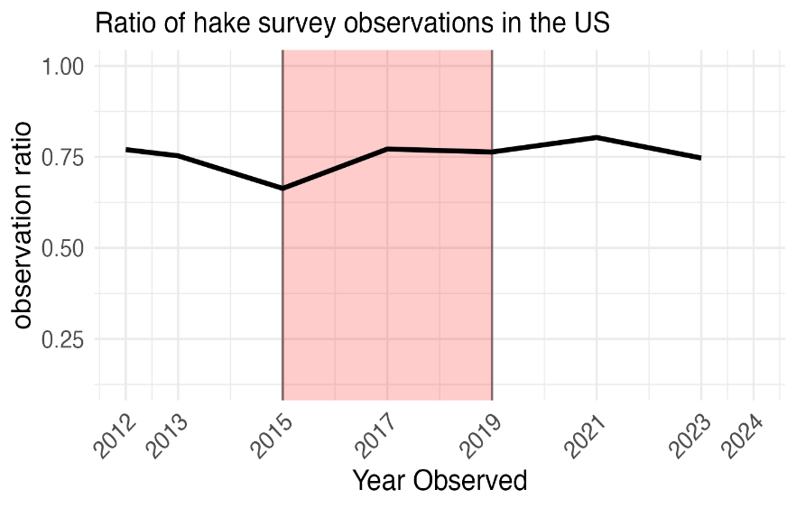

Figure S9: Ratio of the number of survey observations taken in the U.S. to the total number observations taken in the study area. Survey observations are quantified as the transect integral over 0.926 km.

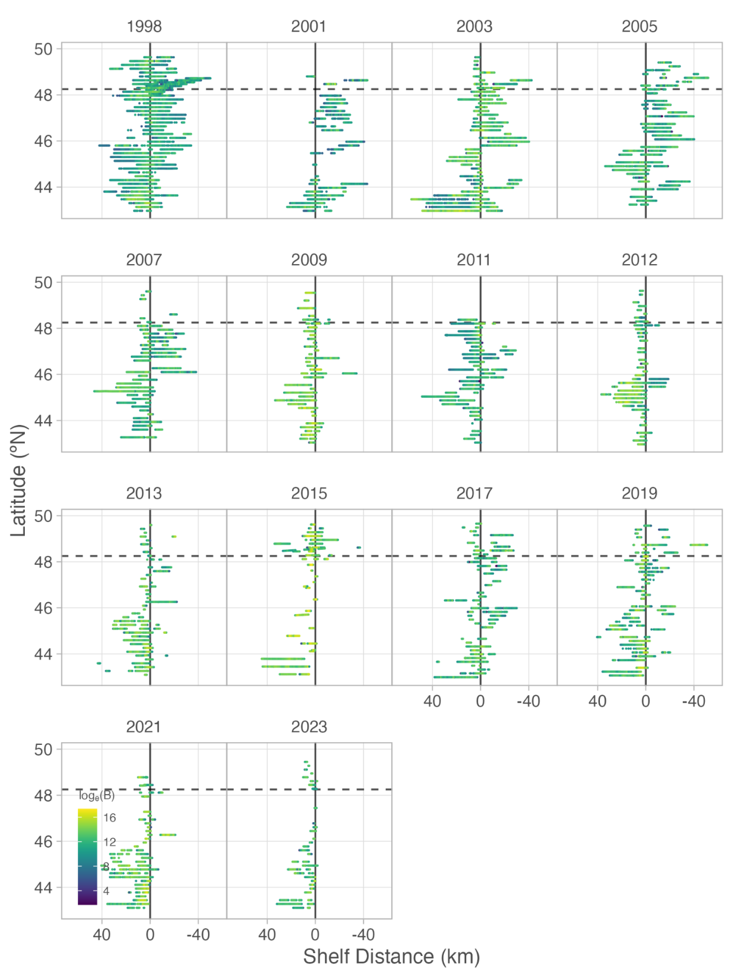
Figure S10: Total hake log biomass observed on the acoustic hake survey, divided across years. The distance to the 200 meter shelf break is on the x-axis, and the latitude is on the y-axis. The vertical solid line shows the shelf break, and the horizontal line shows the approximate latitude of the U.S.-Canada border.
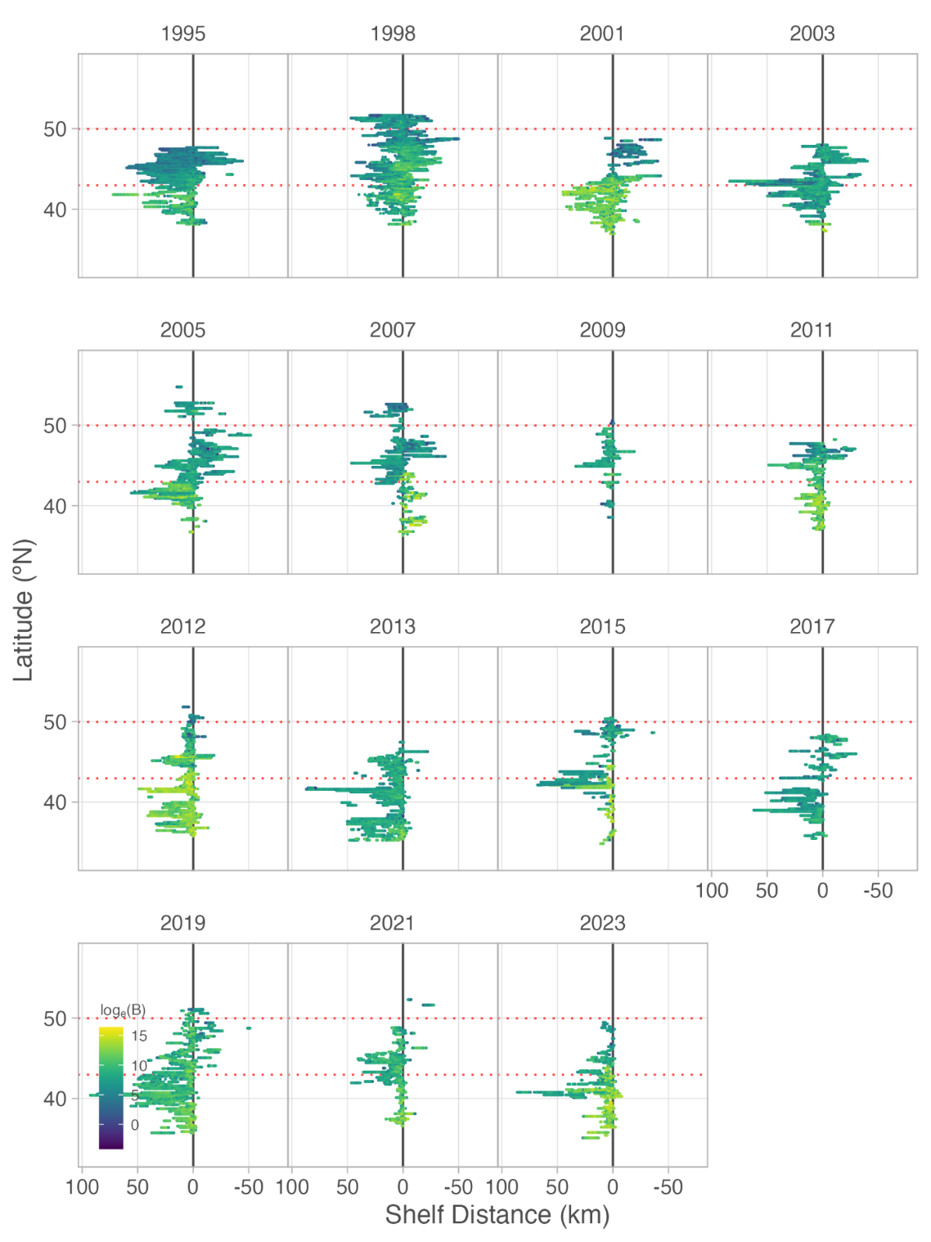
Figure S11: Age 2 hake log biomass across the whole survey extent for each survey year. Red dotted lines show the southern and northern extent of our study region. Across all years, most of the age 2 hake biomass is found south of the study region.

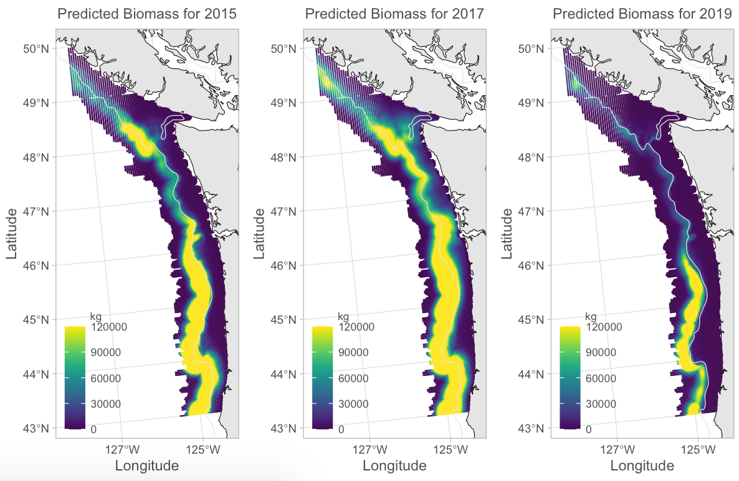
Figure S12: Total hake delta-model reforecast for 2015 (left), 2017 (middle), and 2019 (right).

